FLIP PROJECT - Final output
Here below we can find the data concerning the questionnaires given to the students of three classgroups of“Cattaneo-Deledda” School (1^L, 1^N and 2^N) before and after the flipped methodology practice, in order to analyse the effect and the efficacy of the project.
First of all, let’s give a look to the type of students taking part to the study

The graphsshow how our school is formed: a clear predominance of girls and a great percentage of students with learning difficulties (Dyslexia), special educational needs and learning disabilities or other health or mental problems (*DSA/BES/L104).
Theessaydisplays the data referring to five domains: PERSONALISATION, INNOVATION, TASKS ORIENTATION, COOPERATION, DIFFERENTIATION AND EQUITY.
Students’ answers have been compared before and after the implementation of the Flip project for each of the five domains listed above.
Considering the high percentage of students with learning difficulties (*DSA/BES/L104), it was really interesting to analyse the way these pupils answered to the initial and final questionnaires (comparing them to those of all other students) so to verify the effect of the new methodology in the learning process.
Sometimes it was also necessary to interlace some data of the different domains, to give a more coherent overview and a deeper reflection.

PERSONALIZATION: the extent to which the educational environment stimulates students to participate at the own learning with interest and joy
- PARTICIPATION
CLASS GROUP DSA/BES/OM

CLASS GROUP DSA/BES/L104

Observing the graphs, it is interesting to underline that the project positively involved and increased the personal engagementof the students of the different class groups. In particular, the data referring to the students with learning difficulties, special educational needs or with disabilities (*DSA/BES/L104) show that their participation and involvement is more than doubled compared to other classes. The percentage of the students that didn’t take part to the lessons or that were not involved in the learning activities was null.

- CONTRIBUTION DURING THE ACTIVITIES
CLASS GROUP DSA/BES/L104

- Rhythm of classes
CLASS GROUP DSA/BES/OM

As showed in the graphs above, the new methodology gave students a challenge to try, to prove themselves with no fear or awe to be unsuccessful, in accordance with their own learning rhythm. It’s also worth considering that the percentage of the students *DSA/BES/L104that were not able to keep up with the rhythm of the classes or that didn’t get involved in the activities was null.

- BORE ANDFUN
CLASSGROUP DSA/BES/L104

CLASS GROUP DSA/BES/L104

The graphs show that the FLIP methodology remarkably reduced boredom. In particular, as we can see in the following diagram, the activities used such as Powtoon, Work in pairs, Kahoot achieved resounding success.
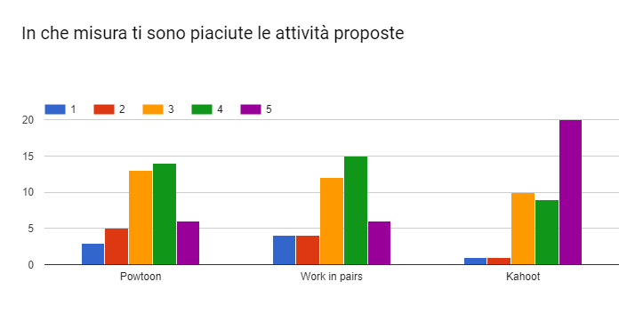
Students DSA/BES/L104liked/appreciated Group work activitiesas well, even if the initial questionnaire showed that the 26% were not interested in them while the 17% were completely indifferent/uncaring about this new methodology.
DIFFERENTIATIONAND EQUITY: the extent to which students are stimulated to be involved in tasks according to their skills and abilities.
The following graphs display what the students stated/declared before the FLIP methodology.

As we can observe even though teachers try to implement inclusive educational activities especially with students with learning difficulties, special educational needs and with disabilities, more than one-third of them find hard to express their opinion to peers because they are afraid to make a mistake/to slip-up(to be wrong).
COOPERATION:the extent to which students cooperate rather than work individually or partecipate in frontal activities

It’s interesting to highlight the higher percentage (64%) of students feeling encouraged to cooperate with their colleagues compared to that of students DSA/BES/L104 (52%)
The activities of the FLIP project eased DSA/BES/L104 students; as a matter of fact the 73% of them confirmed that they felt encouraged to cooperate during Pair work activities and they liked learning from their peers.
INNOVATION: the extent to which the learning process includes developing the transversal skills goals using collaboration, problem solving, investigation, creative thinking activities, use ITC & OER, educational games etc..
- Educational games and ITC
CLASS GROUP *DSA/BES/OM

The graphs display what students affirmed after the implementation of educational games, ITC & OER.

- Homework

- Activities
CLASS GROUP DSA/BES/L104

As we can see, the flipped class methodology overturned students’ answers regarding homework.
- How ICT encouraged students to take part to the educational activities both at school and at home
The following graph shows what students affirmed after the implementation of the FLIP project:

The data emerging from the graph are really interesting if we consider that previously only the 26% of the class group and the 31% of *DSA/BES/L104 had affirmed that they would be more stimulated to be involved during classes if the activities had required usage of electronic devices.
TASK ORIENTATION: the extent to which students are focused on their learning
- Schoolwork and Homework
Class Group DSA/BES/L104

Observing the diagrams above it is clear that the flipped methodology extremely eased the learning process so that students could improve their performance both at school and at home.
Noteworthy is the data referring to students *DSA/BES/L104: the difficulties they had before the implementation of the FLIP project have been reduced (the percentage lowers from the 26% to the 10%).
- Use of electronic devices (computer, tablet, phone)
Class Group DSA/BES/OM

The diagrams clearly/visibly reveal that the number of students employing electronical devices to solve their tasks increased, going from the 18% to the 34%, and it’s interesting to highlight the data referring to *DSA/BES/L104, as the percentage considerably grows from 13% to 41%.

- Awarenessof receiveng practical tasks
Before FLIP project After Flip project

It’s interesting to highlight how “learning by doing” increased the awareness that the tasks received during class activities were practical.
- Teacher availability to give explanations
Class Group DSA/BES/OM

The number of students believing that teachers were ready to give further explanations when they needed them increased going from the 77% to the 86% (considering 4 plus 5) and from 61% to 82% (4 plus 5) for DSA/BES/L104.

